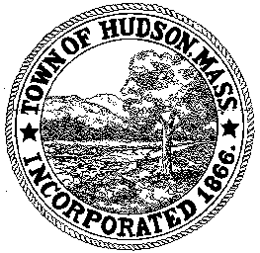

CONSERVATION COMMISSION
78 Main Street, Hudson, MA 01749
(978) 562-2020

Paul Byrne, Chairman W. Minot Wood, Vice Chairman David Esteves, Member

Terrence Joyce, Member Leif Longtine, Member Joseph Rodrigues, Member Al Tashian, Member

Meeting Agenda
May 3, 2012 7:00 P.M.

- Preliminaries
  - Open Meeting
  - Roll Call

2.0 New Business
2.1 Update on WestRidge

2.2 DEP 190-056
Applicant: Kristine and Tom Connor
Location: 61 Brook Street
Project Description: installation of an in ground swimming pool with safety fence and concrete deck. All activities will be done on an existing lawn.

2.3 RDA 422
Applicant: C. Richard and Diana Mundinger
Location: 11 Otsego Drive
Project Description: erection of a 6’ fence and additional landscaping to prevent erosion.

2.4 RDA 423
Applicant: Tom Abrahamsen
Location: 36 Causeway Street
Project Description: removal of a dead tree within buffer zone

2.5 Nicolas and Candis Clare
478 Main Street
Landscaping on wetland property

2.6 Minutes April 19, 2012
2.7 Update on Senior Center
2.8 Forest Avenue School update

3.0 Old Business

4.0 Correspondence
4.1 61 Brook Street – bank stabilization
4.2 54 Brook Street – work completed
4.3 Extension to Order of Conditions 190-0367
4.4 Letter to DEP
4.5 Request for Certificate of Compliance DEP 190-0440

5.0 Adjournment

